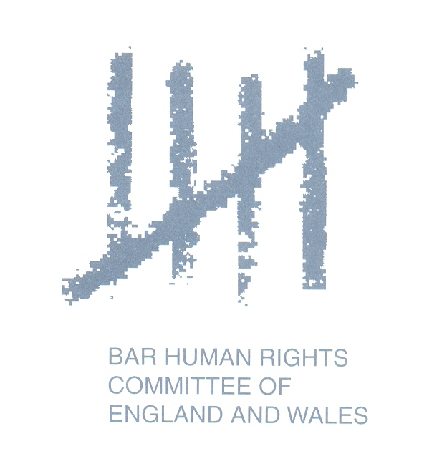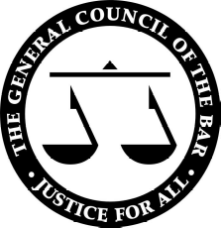

STATEMENT BY THE CHAIRMAN OF THE GENERAL COUNCIL OF THE BAR OF ENGLAND AND WALES AND THE CHAIRMAN OF THE BAR HUMAN RIGHTS COMMITTEE OF ENGLAND AND WALES

The Chairmen of the Bar Council of England and Wales and of the Bar Human Rights Committee of England and Wales express their deep concern at reports on Friday 6th March 2009 of the arrest and detention of magistrate Livingstone Chipadze in Mutare, Zimbabwe.
Mr Chipadze is reported to be accused of criminal abuse of office, apparently on the basis that on Tuesday 3rd March he allowed lawyers for Roy Bennett MP to post bail of $2,000.
Mr Bennett is the MDC’s nominee for agriculture minister in the Zimbabwean Unity Government. However, he has not been sworn in to that post, having been detained on terrorism charges in February.
Mr Bennett was granted bail by Justice Tedius Karwe of the Zimbabwean High Court on Tuesday 3rd March but that decision was overturned on Wednesday 4th March by Justice Paddington Garwe in the Supreme Court upon the Zimbabwean Attorney General’s appeal. Mr Chipadze’s order of Tuesday 3rd March appears to have been in accordance with the High Court order then in force.
The arrest of any judge, save in the most exceptional circumstances, will inevitably raise very serious issues relating to the rule of law. The conduct of Zimbabwean state authorities before the courts has frequently given cause for grave concern. The arrest and detention of Mr Chipadze, apparently because he made a judicial decision that was contrary to the interests of some elements of the Zimbabwean state, is particularly disturbing.
We note reports that other magistrates in Mutare went on strike in support of Mr Chipadze. We have heard unconfirmed reports that Mr Chipadze was released on bail over the weekend but that he still faces criminal proceedings. Whether or not he has been released, his arrest and detention appear to have been serious breaches of the principle of judicial independence.
The signatories to this statement ask the Zimbabwean authorities to abide by the Unity Government’s commitment to the rule of law and immediately to withdraw any criminal charges against Mr Chipadze. Such serious mistreatment of a judicial officer is inconsistent with the rule of law.
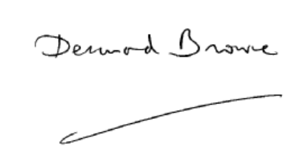
Desmond Browne QC
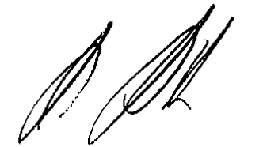
Chairman of the Bar

Mark Muller QC
Chairman of the Bar Human Rights Committee

