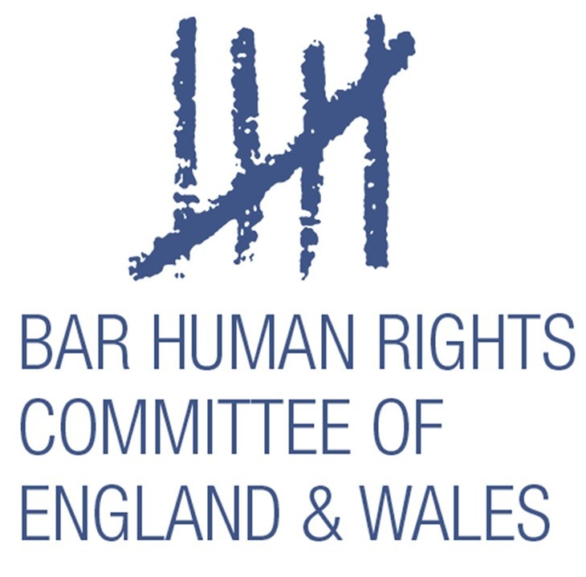

OBSERVATION NOTES

Catalan Referendum Trial

February 2019

Written by Bill Bowring
Executive Committee
Bar Human Rights Committee

Edited by Stephen Cragg QC
Co-Vice Chair, Bar Human Rights Committee

Bar Human Rights Committee of England and Wales
Doughty Street Chambers
53-54 Doughty Street
London WC1N 2LS
England

www.barhumanrights.org.uk

Produced by BHRC
Copyright 2019©

Table of Contents
(DO NOT TOUCH: will automatically update with report)
Bar Human Rights Committee 4
Introduction 5
Acknowledgments 5
Funding 5
The Accused 6
The Alleged Crimes 10
Rebellion 10
Sedition 11
Embezzlement 11
Disobedience 12
Criminal organisation 12
The Three Prosecutors 13
Compliance of the proceedings with domestic and international fair trial standards 14
The ICJ Opinion 14
Observations 16
Discussion 18

The following report is a formal note of a series of trial observations at the Catalan Referendum case from 19 to 20 February 2019. The note is not a formal BHRC trial monitoring report and should not be used for such intended purposes.

Bar Human Rights Committee
The Bar Human Rights Committee (“BHRC”) is the international human rights arm of the Bar of England and Wales. It is an independent body, distinct from the Bar Council of England and Wales, dedicated to promoting principles of justice and respect for fundamental human rights through the rule of law. It has a membership of nearly five hundred lawyers, comprised of barristers practicing at the Bar of England and Wales, legal academics and law students. BHRC’s fifteen Executive Committee members and general members offer their services pro bono, alongside their independent legal practices, teaching commitments and/or legal studies. BHRC also employs a full-time executive officer.
BHRC aims to:
- uphold the rule of law and internationally recognised human rights norms and standards;
- support and protect practicing lawyers, judges and human rights defenders who are threatened or oppressed in their work;
- further interest in and knowledge of human rights and the laws relating to human rights, both within and outside the legal profession;
- support and co-operate with other organisations and individuals working for the promotion and protection of human rights; and
- advise the Bar Council of England and Wales in connection with international human rights issues.

As part of its mandate, BHRC undertakes legal observation missions to monitor proceedings where there are concerns as to the proper functioning of due process and fair trial rights. The remit of BHRC extends to all countries of the world, apart from its own jurisdiction of England and Wales. This reflects the Committee's need to maintain its role as an independent but legally qualified observer and critic.

Introduction

I visited Madrid on Tuesday 19 and Wednesday 20 February, invited (at extremely short notice) by International Trial Watch – Catalan Referendum Case, which is a coalition of civil society organisations:
• Associacio Catalana per a la Defensa deis Drets Humans (ACD ddhh)
• Col-lectiu PRAGA
• Institut de Drets Humans de Catalunya
• Iridia - Associació Irídia, Centre per la Defensa dels Drets Humans
• NovAct International Institute for Nonviolent Action
• OSPDH - Observatorio del Sistema Penal y los Derechos Humanos (OSPDH) de la Universidad de Barcelona

- I represented the European Lawyers for Democracy and Human Rights (ELDH), of which I am President, and the Bar Human Rights Committee of England and Wales (BHRC) of which I am an Executive Committee Member.

- I was one of three international observers on those days. The others were John Philpot, Avocat, practising in Montréal, Canada and Paul Newman, Lawyer in Bangalore, India. It should be noted that on the first day that no translation of proceedings was available and any observations and conclusions must be considered with that in mind.

Acknowledgments
- I am grateful for the support I received from Anais Avo and Andres Garcia, lawyers and activists in Iridia; and from Professor Louis Lemkow Zetterling, of the Institut de Ciència i Tecnologia Ambientals - Universitat Autònoma de Barcelona (ICTA-UAB). I now have close contact with all three.

Funding
- Expenses for the mission were funded by International Trial Watch – Catalan Referendum Case. BHRC, however, conducted the trial observations and wrote these notes on an independent and pro bono basis.

The Accused
- The 12 Accused are:

Oriol Junqueras Vies  Prosecutor’s request: 25 years in prison for rebellion and misuse of public funds | Former Catalan vice president and ERC leader  Oriol Junqueras is the most senior political figure to face trial in the Supreme Court. He was the Catalan vice president and the finance minister at the time of the referendum, as well as the main independence leader along with then-president Puigdemont. While Puigdemont left the country following Madrid’s takeover of Catalan institutions, Junqueras stayed and was subsequently incarcerated on November 2, 2017. While in prison, he ran as ERC’s candidate for president in the December 21 election.  Pro-independence parties had held on to a parliamentary majority but lost it last spring when the Supreme Court suspended Junqueras and other MPs charged in the Catalan trial, and they rejected being replaced. Junqueras will have spent 467 days in precautionary detention by the time the trial starts.
Jordi Turull Negre  Prosecutor’s request: 16 years in prison for rebellion and misuse of public funds | Former regional minister for the presidency and spokesman for the government of Catalonia  As the presidency minister and cabinet spokesperson, Jordi Turull was one of the highest-ranking government officials during the independence referendum. He entered prison on November 2, 2017, only to be released a month later on a €100,000 bail.  Elected as an MP for Junts per Catalunya (JxCat) party, led by Puigdemont, he was proposed by the former president as his successor, when Spanish courts prevented Puigdemont from retaking the post at a distance. He entered prison again on March 23, a day before he was to be elected as Catalan president in parliament.  He was subsequently suspended as MP, and prevented from retaking his post as presidency minister while in prison. Turull will have spent 359 days in precautionary detention when the trial starts.
Joaquim Forn Chiarello  Prosecutor’s request: 16 years for rebellion and misuse of public funds | Former regional interior minister  As the interior minister, Joaquim Forn was in charge of Catalonia’s own police force, the Mossos d’Esquadra, during the independence referendum. Accused of not doing enough to stop the vote, Forn has denied any "political interference" with the Mossos’ work.  Along with Junqueras, Forn is the only minister who’s stayed behind bars consistently since November 2. He is to run for Barcelona mayor as JxCat’s candidate. Forn will have spent 467 days in precautionary detention when the trial starts.
Raül Romeva Rueda  Prosecutor’s request: 16 years for rebellion and misuse of public funds | Former regional minister for foreign affairs, institutional relations and transparency  After a decade serving as a member of the European Parliament for the Greens-EFA, Romeva returned to Catalonia in 2015 to lead pro-independence parties in a unity list.  He served as foreign action minister until Spain triggered Article 155 of the constitution to suspend the Catalan government, following a declaration of independence. He spent a month in jail, was released on bail, and was later re-imprisoned in March 2018. Elected as an MP for ERC, the Supreme Court suspended him last July. Romeva will have spent 359 days in precautionary detention when the trial starts.
Dolors Bassa Coll  Prosecutor’s request: 16 years for rebellion and misuse of public funds | Former social affairs minister  Dolors Bassa was the minister of social affairs when the referendum took place. She was released on bail after spending a month in prison from November to December 2017.  A member of ERC, she left her seat in parliament before appearing before the Supreme Court in March last year but was imprisoned regardless. Bassa will have spent 359 days in precautionary detention when the trial starts.
Josep Rull Andreu  Prosecutor’s request: 16 years for rebellion and misuse of public funds | Former minister for land and sustainability  A close ally of Puigdemont, Josep Rull has served as a member of the Catalan parliament for more than two decades. After spending one month in jail and being released on bail, he was imprisoned again last March.  Catalan president Quim Torra proposed that he retake his post as territory minister while in prison, but Spanish courts blocked his appointment and later suspended him as an MP. Rull will have spent 359 days in precautionary detention when the trial starts.
Meritxell Borràs Sole  Prosecutor’s request: 7 years in prison + €30,000 fine for misuse of public funds and disobedience | Former regional minister for governance, public administration and housing  Catalonia’s governance minister during the independence referendum, Meritxell Borràs quit politics after spending 33 days in prison, thus abandoning a career spanning more than 20 years. Summoned to court last March, she was allowed to walk free while most of her colleagues were again incarcerated.
Carles Mundó Blanch  Prosecutor’s request: 7 years in prison + €30,000 fine for misuse of public funds and disobedience | Former justice minister  Just like Borràs, Carles Mundó quit politics after spending 33 days in jail in late 2017 for his role in the independence bid. He was the justice minister during the referendum.
Santi Vila i Vicente  Prosecutor’s request: 7 years in prison + €30,000 fine for misuse of public funds and disobedience. | Former regional minister for business and knowledge  Santi Vila was always sceptical of unilateral moves to independence while a member of the Puigdemont cabinet. He was part of the government when the referendum was called, and the day before the declaration of independence, he stepped down from his post and from politics altogether soon afterward. This, after spending one day in prison. He was not MP in Parliament during that period, and said his department spent no money on referendum logistics.
Carme Forcadell Liuis  Prosecutor’s request: 17 years in prison for rebellion. | Former parliament speaker  Forcadell has been one of the main key players in the road to independence since its beginning in 2012. The first years, she was leader of a large grassroots pro-independence organization, the Catalan National Assembly (ANC), and from 2015 as parliament speaker.  The Spanish Constitutional Court sent her several warnings and the Spanish prosecutor filed criminal lawsuits against her while in office, for allowing debates and votes on independence. Forcadell, however, repeatedly stated that she always respected freedom of speech and the rights of MPs. She will have been behind bars for 327 days when the trial starts.
Jordi Sànchez Picanyol  Prosecutor’s request: 17 years in prison for rebellion. | Former grassroots leader  Jordi Sànchez took over ANC leadership in 2015 when Forcadell entered institutional politics. He led a protest outside the Catalan economy department on September 20, 2017, as a response to Spanish police raids against the referendum organization.  No-one was injured but the protest was considered a “tumultuous” one, and Sànchez was charged with sedition, and then rebellion. The grassroots leader maintains all pro-independence demonstrations in that period were peaceful. Yet he was incarcerated pending the trial, and when sessions start, he will have spent 484 days behind bars.  While in jail, he stepped down as ANC leader, was elected as MP for Puigdemont’s candidacy JxCat, attempted to be sworn in as Catalan president, and was then suspended as MP.
Jordi Cuixart Navarro  Prosecutor’s request: 17 years in prison for rebellion. | Grassroots leader  Jordi Cuixart is the only official to be judged who has never held any public post in politics. During the 2017 referendum, he was president of Òmnium Cultural, another large pro-independence organization, and is accused of the same events as Sànchez. Both were the first leaders to be sent to precautionary jail in October 2017, and Cuixart will also have spent 484 days in prison when the trial starts.  Unlike Sànchez, he was not involved in the December 2017 election and remained Òmnium’s leader. This organization has dramatically increased its members since then, to 130,000.
- All the elected politicians would be barred from holding public office for long periods of years if convicted.

The Alleged Crimes

- The accused are charged with the following crimes arising out of the organisation of the independence referendum on 1 October 2017.

Rebellion
Article 472
A conviction for the offence of rebellion shall be handed down to those who violently and publicly rise up for any of the following purposes:
1. To fully or partially repeal, suspend or amend the Constitution;
…
5. To declare the independence of any part of the national territory
…
7. To disaffect from obedience to the Government any armed force.

Article 473
- Those who, inducing the rebels, have promoted or sustain the rebellion, and its ringleaders, shall be punished with a sentence of imprisonment from fifteen to twenty- five years and absolute barring for the same time; those who act as subaltern commanders, with that of imprisonment from ten to fifteen years and absolute barring from ten to fifteen years, and mere participants, with that of imprisonment from five to ten years and special barring from public employment and office for a term from six to ten years.

- If weapons have been used, or if there has been combat between the rebellious force and the sectors loyal to the lawful authority, or when the rebellion has caused criminal damage to publicly or privately owned property, cutting off telegraphic and telephone lines, the airwaves, railways or any other kind of communications, with serious violence against persons, demanding contributions or diverting the public funds from their lawful investment, imprisonment shall be handed down, respectively, of twenty- five to thirty years for the former and from fifteen to twenty- five years for the second, and from ten to fifteen years for the latter.

Article 478
Should whoever commits any of the felonies foreseen in this Chapter be an authority, the punishment of barring foreseen in each case shall be substituted by that of absolute barring for a term from fifteen to twenty years, except if that circumstance is specifically included in the criminal classification concerned.

Sedition
Article 544
Conviction for sedition shall befall those who, without being included in the felony of rebellion, public and tumultuously rise up to prevent, by force or outside the legal channels, application of the laws, or any authority, official corporation or public officer from lawful exercise of the duties thereof or implementation of the resolutions thereof, or of administrative or judicial resolutions.

Article 545
- Those who have induced, sustained or directed the sedition or who appear as the main doers thereof, shall be punished with a sentence of imprisonment from eight to ten years, and with that ten to fifteen years if they are persons with the status of an authority. In both cases, absolute barring for the same term shall also be imposed.

- Apart from those cases, a punishment from four to eight years imprisonment and of special barring from public employment and office for a term from four to eight years shall be imposed.

Embezzlement
Article 432

- The authority or public officer who, for profit, steals or allows a third party, with the same intention, to steal public funds or property he has under his charge due to his duties, shall incur a sentence of imprisonment from three to six years and absolute barring for a term from six to ten

- A sentence of imprisonment shall be imposed from four to eight years and that of absolute barring for a term of ten to twenty years, if the embezzlement is especially serious, in view of the value of the sums embezzled and the damage or hindrance caused to the public The same penalties shall be applied if the items misappropriated are listed due to their heritage or artistic value, or if they are goods assigned to public catastrophe relief.

- When the amount embezzled does not reach the sum of 4,000 euros, the penalties imposed shall be a fine exceeding two and up to four months, imprisonment from six months to three years and suspension from public employment and office for a term of up to three

Disobedience
Article 410

- Authorities or civil servants who openly refuse to duly fulfil court resolutions, decisions or orders of a higher authority, handed down within the scope of their respective powers and complying with the legal formalities, shall be punished with a fine from three to twelve months and special barring from public employment and office

Article 73
Authorities or civil servants who openly refuse to duly fulfil court resolutions, decisions or orders of a higher authority, handed down within the scope of their respective powers and complying with the legal formalities, shall be punished with a fine from three to twelve months and special barring from public employment and office

Article 74
- Notwithstanding what is set forth in the preceding Article, whoever perpetrates multiple actions or omissions, in the execution of a preconceived plan or taking advantage of an identical occasion, that offend one or several subjects and infringe the same criminal provision or provisions that are equal to or of a similar nature, shall be punished as the principal of a continued felony or misdemeanour with the punishment stated for the most serious offence, that shall be imposed in its upper half, it being possible to reach the lower half of the higher degree of punishment.

Criminal organisation
Article 570 bis

- Whoever promotes, constitutes, organises, co-ordinates or directs a criminal organisation shall be punished with a sentence of imprisonment from four to eight years, if it has the purpose or object of committing serious felonies, and with a sentence of imprisonment from three to six years in other cases; and whoever actively participates in the organisation, forms part thereof or co-operates financially or in any other way therein, shall be punished with imprisonment from two to five years if its purpose is to commit serious felonies, and with a sentence of imprisonment from one to three years in other.

For the purposes of this Code, a criminal organisation is construed to be a stable group formed by one or more persons, for an indefinite term, in collusion and co-ordination to distribute diverse tasks or duties in order to commit felonies, as well as to carry out reiterated commission of misdemeanours.

- The penalties foreseen in the preceding Section shall be imposed in the upper half when the organisation:
  - is formed by a large number of persons;
  - possesses weapons or dangerous instruments;
  - has advanced technological resources for communication or transport that, due to their characteristics, are especially fit to facilitate commission of the offences or the impunity of the accused.

Should two or more of those circumstances concur, the higher degree penalties shall be imposed.

The three prosecutors
- There are three prosecutors:

Public Prosecution Ministry
The Public Prosecution Ministry, without prejudice to the functions entrusted to other bodies, has as its mission, the promotion of Justice in defence of the rule of law, the rights of citizens and the public interest protected by the Law, ex officio or at the request of the interested parties, as well as to ensure the independence of the Courts and to seek before them the promotion of social interest (art. 124 EC). The Public Prosecution Ministry exercises its functions through its own bodies, in accordance with the principles of unity of operation and hierarchical subordination subject in all cases, to the rule of law and impartiality. The basic law that regulates the Spanish Public Prosecution Ministry is the Organic Statute of the Public Prosecution Ministry, approved by Law 50/81, of 30th December, and modified by Law 24/2007, of 9th October. The Public Prosecution Ministry is a single body for the entire State and its members are the authority for all purposes, always acting as representatives for the whole Institution.

Solicitor General of the State
The Solicitor General of the State represents the State and depends functionally on the Ministry of Justice. It is the governing body for the services that provide legal assistance to the State and to other public institutions. It is led by the Solicitor General of the State and appointed by the Council of Ministers.

People’s Prosecution
A concept regulated in Article 125 of the Spanish Constitution, giving legitimacy to any citizen to present themselves in a criminal judicial process, even if they have not been directly affected by the crime in question. It is a form of civic participation in the justice system and characteristic to Spain; it does not exist in other countries. Even though it is permitted both for individuals and corporate entities, it is very common for it to be carried out by groups, associations or even political parties.

The people’s prosecution is being carried out by VOX, the far-right political party in Spain founded on 17 December 2013, by former members of the People's Party (PP).

Compliance of the proceedings with domestic and international fair trial standards

The ICJ Opinion
- I agree with the position of the International Commission of Jurists (ICJ) published on 12 February 2019:

The very broad definition of the offence of rebellion being applied in this case risks unnecessary and disproportionate interference with rights of freedom of expression, association and assembly. The twelve political leaders – including high-ranking Catalan government officials – have been charged in connection with their part in the administration on 1 October 2017 of a referendum on Catalonian independence. The referendum was conducted despite having been declared illegal by the Constitutional Court.

The voting process during the referendum was partially suppressed by the police, with credible reports of the use of unnecessary and disproportionate force in breach of Spain’s international law obligations.

Interference with peaceful political expression and protest must be justified as strictly necessary and proportionate under international human rights law. Where peaceful protests or political actions, even if declared unlawful by the authorities, provoke an excessive response by the police, it is solely the police and other state authorities who should be held responsible for the violence. It is crucial that the Supreme Court, in its consideration of these charges, takes full account of Spain’s obligations under international human rights law.

The ICJ is concerned that prosecutors, and the Supreme Court in admitting the indictment in the case, have ascribed an unduly broad meaning to the offence of “rebellion” under article 472 of the Criminal Code. According to that article, the offence requires violent insurrection to subvert the constitutional order. But the referendum organizers are not accused of using or advocating violence. Rather, they are being tried on the basis that they should have foreseen the risk of intervention and the use of force by the police. It is therefore alleged that the defendants were criminally responsible for the violence that ensued from their decision to carry on with the referendum, despite it being declared illegal.
Although the Supreme Court has held that the use of force by Spanish law enforcement authorities during the repression of the referendum of 1 October 2017 was “legitimate and, as such proportionate”, international observers have concluded that such use of force was excessive and disproportionate. In accordance with international human rights law, the mere fact that the use of force is considered to be legal under national law, does not of itself mean that it can be considered to be necessary and proportionate.

The Supreme Court has further already accepted that, if the facts alleged by prosecutors are proven, they could amount to the offence of sedition, which is committed by those that that rise up publicly and in a tumultuous way, by force or by unlawful means, to impede the implementation of laws or of authorities’ orders.

Vague, broadly defined offences of sedition or rebellion risk violation of the principle of legality, as well as arbitrary and disproportionate interference with human rights. In a highly sensitive and politicised case such as that of the Catalonian referendum, they would set a dangerous precedent for the targeting of peaceful independence movements and political dissent, not only in Spain but internationally.

Several of the accused have already been held in pre-trial detention for lengthy periods, further exacerbating the severity of the interference with rights to freedom of expression, association and assembly, and casting doubt on the proportionality of the response.

Observations
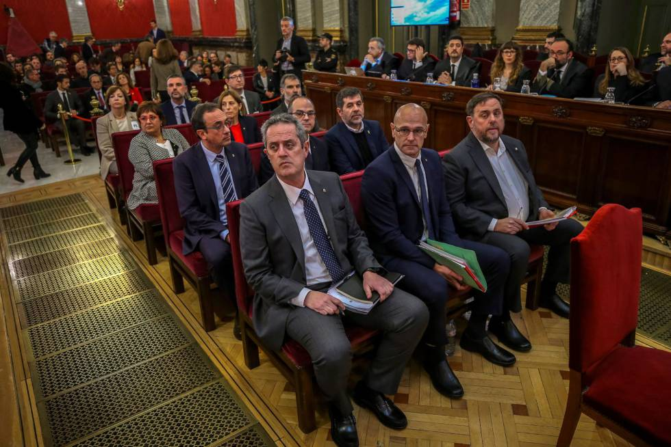
- I arrived in Madrid on the morning of 19 February and attended the hearing at the Supreme Court in the afternoon. I and the other two observers were not hindered in entering the court or the large, ornate court-room.
Figure 1: The Accused (Photo from El Pais, EMILIO NARANJO GTRES)

- The judges sit at the head of the court-room (see Figure 2).

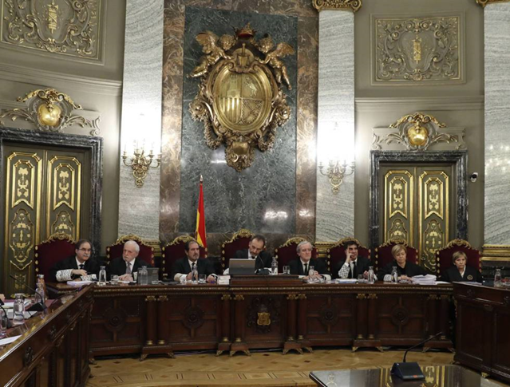
- The presiding judge, with a 7 judge panel, is Justice Manuel Marchena Gomez. He is the President of the Criminal Chamber of the Court. He was born in 1959, 59 years old. He has been a prosecutor, judge, and professor.
Figure 2: The Judges (Picture from El Pais, J.J.GUILLEN EFE)

- The other judges are:
- Antonio del Moral Garcia
- Luciano Varela Castro
- Andrés Martinex Arrieta
- Juan Ramón Berdugo Gómez de la Torre
- Ana Maria Ferrer Garcia
- Andrés Palomo del Arco

- According to the Catalan newspaper, El Nacional:

[Judge Marchena] has let the defence lawyers have twice as much time to make their points as they are allowed, according to the jurisprudence of the European Court of Human Rights (ECHR) - the court whose presence hangs permanently over this courtroom. He has let family members enter the Supreme Court room where the accused are held during recesses. He has let the accused wear yellow ribbons. He did not cut off the political discourse of Oriol Junqueras, even though he had warned he didn't want political meetings. Indeed, the seven judges who are hearing the independence leaders' case remained silent and unfazed, and at no time interrupted the former Catalan vice-president, but rather, simply listened attentively, without making notes of any kind.

Marchena has allowed the prisoners to sit alongside their lawyers. Although it will have to be behind them, since the number of defence lawyers is so large, they won't all fit right beside their clients.

Manuel Marchena was especially severe with the public prosecutor and the state solicitor, and also with the private prosecution led by Vox, of course. And strict he will have to be, because Vox's status as a political party - combined with the calling of a Spanish general election - further complicates the role of this private prosecution and of Manuel Marchena himself, who has to act as referee.

- The accused, as appears in the photo above, sat in the centre of the Court, with defence lawyers with them or to their left, and the prosecutors on the right. There were empty seats in the rear of the court, with seats reserved for the press, for the families, and for the public. The presence of international observers was not announced.

- I had no translation during the session I observed, so I could not know whether the defence lawyers told the judges of the presence of observers, nor could I understand what was said.

- I heard Raül Romeva, the former Foreign Action Minister, give evidence. He was not interrupted by the judges and spoke at length. He showed a video of a large, peaceful demonstration in Barcelona. The few interventions made by Judge Marchena appeared to be normal and restrained.

- I was told that most of the defendants have agreed to answer questions from the Public Prosecutor and Solicitor General, but not from VOX.

- In the evening the international observers had dinner in the hotel with some of the defence lawyers. We were told of the extreme and disproportionate nature of the charges against their clients, but we were not told of any hindrance suffered by the defence.

- On the morning of 20 February, I was not taken back to the Supreme Court, but to a room in what appeared to be a temporary office centre, where there was a large TV screen with direct transmission from the Supreme Court, and excellent simultaneous translation into English. It was thus possible to see the judges, prosecutor, and accused close-up.

- I saw Josep Rull, the former Territory Minister, answering questions from the Public Prosecutor. The questioning was restrained and not aggressive, and Mr Rull spoke as long as he wanted to in answer. He was reminded a couple of times by Judge Marchena to try to answer the questions put to him, and not to make so many political points. But he was not hindered in saying what he wanted to say.

- I was struck by the fact the Prosecutor did not ask Mr Rull any questions relating to violence, which is an essential ingredient of “rebellion”. Questions were directed much more to the misuse of public funds in organising a referendum which the Constitutional Court had declared to be illegal.

- I was obliged to leave to return to England after lunch.

- Although it had been intended that I should give interviews to the Spanish and Catalan media, this did not happen. It had also been intended that I should meet Senator Laura Castel from Tarragona, but this did not happen either.

Discussion

- I entirely agree with the assessment of the International Commission of Jurists that to charge these twelve accused, leading Catalan politicians and members of civil society, with such vague, broadly defined offences of rebellion and sedition, carrying lengthy terms of imprisonment, risks violation of the principle of legality, as well as amounting to an arbitrary and disproportionate interference with human rights, especially freedom of expression and freedom of assembly (Article 10 and 11 ECHR). The use of violence by the accused is an essential ingredient of the offence of rebellion under Article 472 of the Spanish Criminal Code. It is therefore especially shocking, that while the referendum on 1 October 2017 was planned as an entirely non-violent expression of a widely held desire for independence as an exercise of the right to self-determination of the Catalan people in international law, the allegation against the accused is that they should have foreseen the perpetration of egregious violence by the Spanish police, and are thus responsible for it.

- The hearings I observed were conducted correctly by the seven judges of the Supreme Court, but it is disturbing that Spanish law permits three simultaneous prosecutions, by the Public Prosecution Ministry, by the Solicitor General of the State, and by VOX, the recently established far-right political party. This, together with the nature of the allegations, tends to undermine the right of the accused to a fair trial (Article 6 ECHR). Finally, holding the accused in custody for such a long period may amount to a violation of the right to personal liberty (Article 5 ECHR).”

https://internationaltrialwatch.org/en/homepage/
https://iridia.cat/
http://www.ub.edu/ospdh/es/presentacion-0
http://www.catalannews.com/catalan-trial/item/who-are-the-catalan-leaders-accused-in-the-independence-trial

