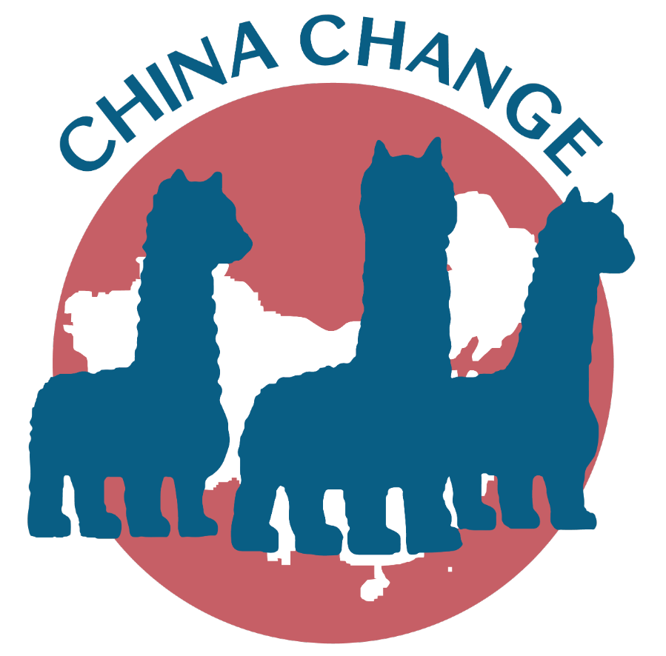
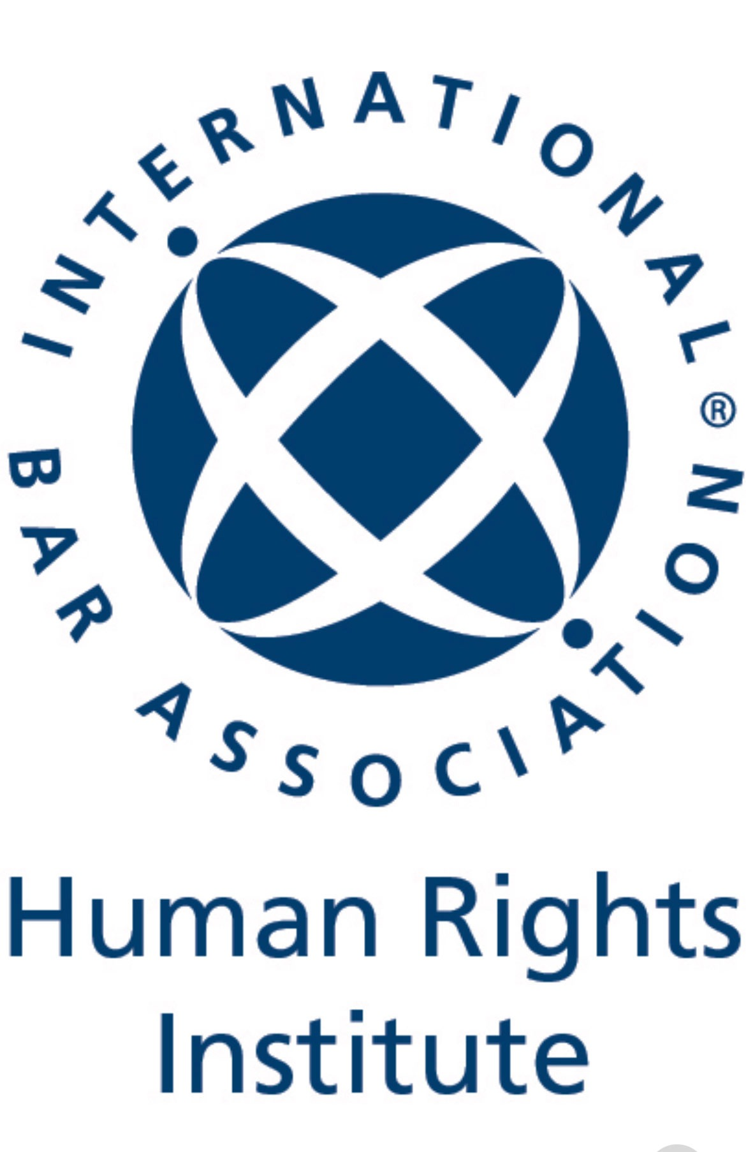
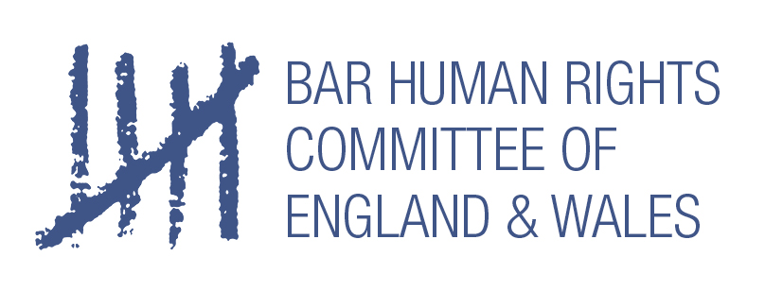
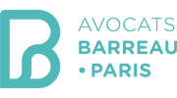
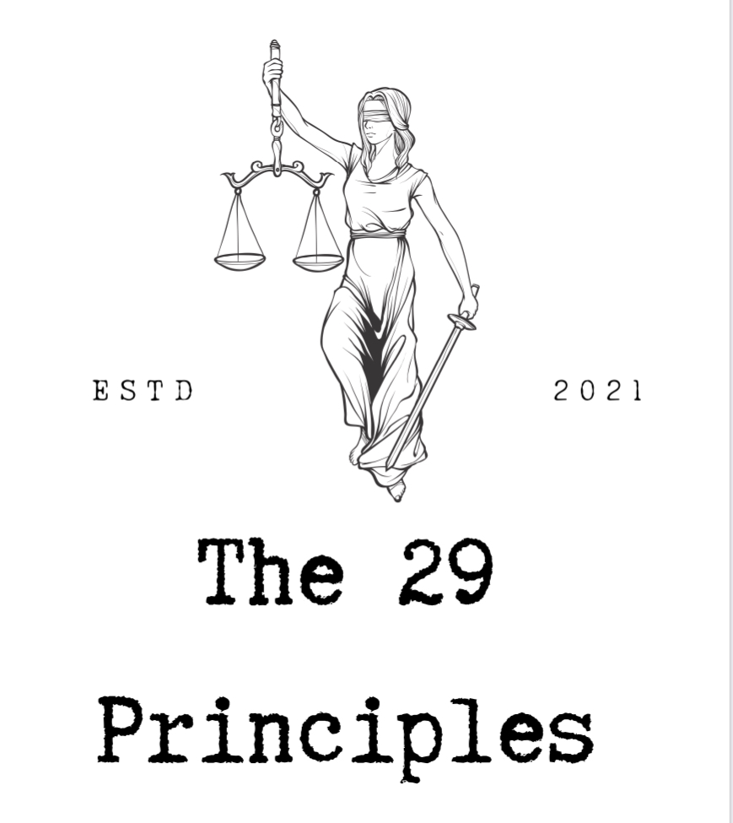
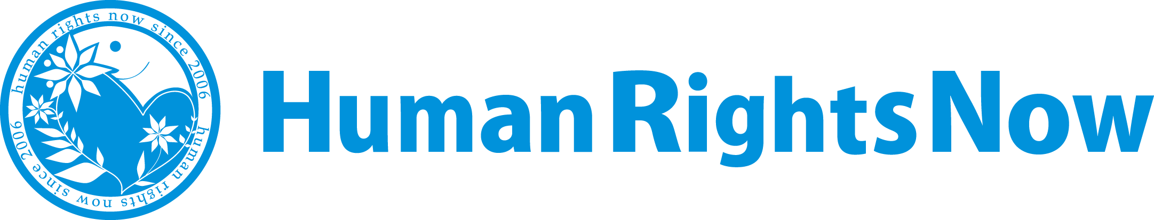
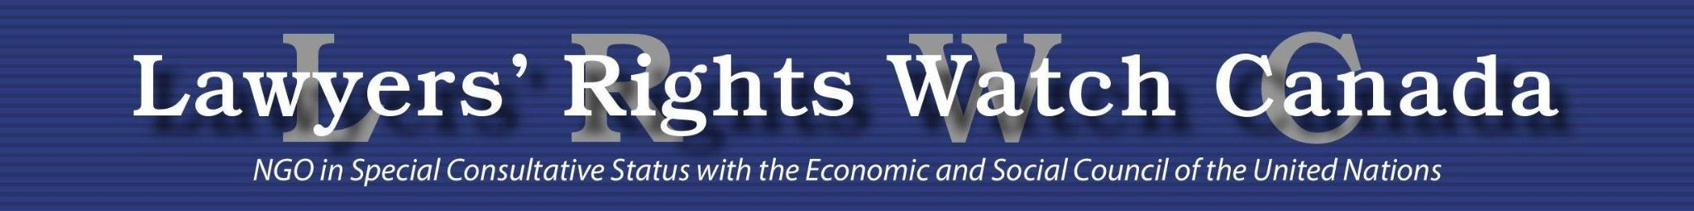

9 December 2021
China must release imprisoned journalist Zhang Zhan, who is at imminent risk of death
The 29 Principles, Lawyers' Rights Watch Canada, the International Bar Association's Human Rights Institute (IBAHRI), Bar Human Rights Committee of England and Wales, Paris Bar Association, Taipei Bar Association’s Human Rights Committee, Human Rights Now, and China Change, call on Chinese authorities to grant medical parole to citizen journalist and former lawyer Zhang Zhan, who was sentenced to four years in prison in December 2020 after being detained for documenting the government’s response to COVID-19 in Wuhan, Hubei province. Zhang’s health is rapidly deteriorating, and her family says she will not make it through the winter if she is not released soon.
Zhang Zhan was detained for “picking quarrels and provoking trouble”, a vague charge routinely used against dissidents, lawyers, and journalists who dare to speak out against injustice or abuse. She was later charged with spreading false information about the situation in Wuhan in early 2020. In protest against her detention and these charges, Zhang Zhan went on hunger strike, and her health deteriorated to the point that she was in a wheelchair for her trial in December 2020.
In July 2021, Zhang Zhan was hospitalised for nearly two weeks due to malnutrition, but she was later returned to prison. Authorities have imposed months of brutal punishment for her protest, which according to individuals familiar with her situation included 24-hour shackles and handcuffs. Her mother recently reported that Zhang is extremely weak and now weighs less than 40 kilograms.
Zhang Zhan was detained, charged and convicted in secret, with extremely limited access to her lawyers and no visits from her family. No solid evidence of a crime was presented in court, except that Zhang was reporting on the local response to the COVID-19 pandemic, rights guaranteed to her under China’s constitution. She continues to insist she is innocent of any crime, and to protest against the restriction of free speech and information in China.
According to Zhang’s former lawyer Ren Quanniu, whose license to practice law has been revoked by Chinese judicial authorities, Zhang’s severe punishment is being used as a warning to others who might dare to reveal “sensitive” information or challenge the government’s propaganda machine.
On 19 November 2021, the United Nations human rights office called for Zhang’s “immediate and unconditional release” on humanitarian grounds. Governments including the EU, US, and UK have done the same. In November 2021, more than 1250 Chinese lawyers and individual citizens have signed an open letter calling for the government to release Zhang Zhan. In September 2021, a coalition of 45 NGOs wrote to Chinese leader Xi Jinping called for Zhang to be released immediately due to hear declining health.
Before turning to citizen journalism, Zhang Zhan was a lawyer, but she was suspended from practice after she spoke up on human rights issues, including signing a statement to protesting the amendments on the regulations on managing lawyers and law firms in 2018.
Zhang Zhan has been imprisoned for no more than telling the truth. She has committed no crime, but has been subject to a harsh and arbitrary punishment that makes a mockery of China's international human rights obligations to ensure fair trial and humane prison conditions, as well as Chinese law and legal process. The 29 Principles, Lawyers' Rights Watch Canada, International Bar Association's Human Rights Institute (IBAHRI), Human Rights Now, China Change (and other organisations) call on the Chinese government to:
- Immediately and unconditionally release Zhang Zhan from detention;
- Provide her with any needed medical care;
- Allow her family to have free and unrestricted access to her.

